WHAT AFFECTS PUBLIC WILLINGNESS TO CONSERVE COASTAL AREAS?

Ryo Sakurai, Ritsumeikan University, ryo223sak@gmail.com

Takahiro Ota, Nagasaki University

Takuro Uehara, Ritsumeikan University

Ken’ichi Nakagami, Ritsumeikan University

Abstract. Public involvement in conservation and management of coastal areas is important especially in those countries, such as Japan, where fishermen are decreasing. Both local residents living adjacent to the ocean and urban residents could contribute to sustainable management of coastal areas through various activities. In order to effectively foster public participation in sustainable management of coastal areas, factors that affect people’s behavioral intentions for coastal conservation need to be identified. We conducted studies to understand cognitive factors affecting residents’ 1) willingness to invest in time and efforts to make a coastal area a better place, and 2) willingness to make financial sacrifices for the sake of the coastal area. Questionnaire survey was distributed around Hinase Bay (western part of Japan). Total of 2,851 responses were collected. Multiple regression analysis revealed that residents’ willingness to know more about wildlife of the coastal area had the strongest effect on their behavioral intentions for conservation of the coastal area. Our findings followed the findings of the previous study conducted in northern part of Japan and revealed that residents living in different regions showed similar cognitive mechanism regarding their intentions for conserving coastal areas. Suggestions for fostering public participation in coastal conservation included promoting wildlife and biodiversity of coastal ecosystems to residents. These outreach programs could increase residents’ interests and curiosity toward wildlife which would consequently raise their willingness to contribute to coastal conservation.

Key words: behavioral intentions, coastal management, conservation, Japan, residents

I. INTRODUCTION

In order to sustainably and effectively manage coastal areas, participation of not only fishermen but also local residents is important. Local residents could contribute to sustainable management of coastal areas through volunteer activities, recreation, donation, consumption (of fishery) and/or actively participating to decision making process. Especially, in such countries like Japan, where fishermen are decreasing rapidly and population of rural areas including fishing hamlets are shrinking [1], encouraging citizen to get involved in coastal management has become critical.
While participation of local residents could be important for sustainable management of coastal areas, historically, research regarding fishery management were dominated by natural science; such as understanding number and dynamics of fish [2]. Accumulating studies based on social scientific approach regarding sustainable and participatory management of coastal areas would be important to understand and predict success of effective coastal conservation.
In this study, we conducted a questionnaire survey to understand cognitive factors that influence residents’ willingness to protect a coastal area. Based on our previous study conducted in Shizugawa Bay, northern part of Japan [3], we examined residents’ perceptions in a different study site; Hinase Bay, western part of Japan. We aimed to understand factors that affect residents’ willingness to conserve coastal areas and if they are similar throughout the region.

II. Study site
Hinase town is located in western parts of Japan, Okayama prefecture, in the coast of Setonaikai (Figure 1). Hinase is located in Bizen city and has a population of about 7,700 in 35.91 km². Fishery had been a thriving industry in Hinase and in 1800s, almost all the households were involved in fishery [4]. Although number of fishermen has decreased, fishery is still active around the Hinase bay.
Japan is famous for having many Satoumi sites (Sato means village and umi means ocean in Japanese) where people have been maintaining or improving the level of biodiversity and productivity through positive interaction of people and natural environment [5]. When water was once polluted by industrial wastes, the fish harvest decreased around Hinase region. In order to solve this issue, local fishermen in Hinase collaborated and started to sow eelgrass seeds which consequently succeeded in increasing the fish harvest [5]. Hinase is famous as a Satoumi site because of these efforts by fishermen, and for this reason, we selected Hinase as our study site.

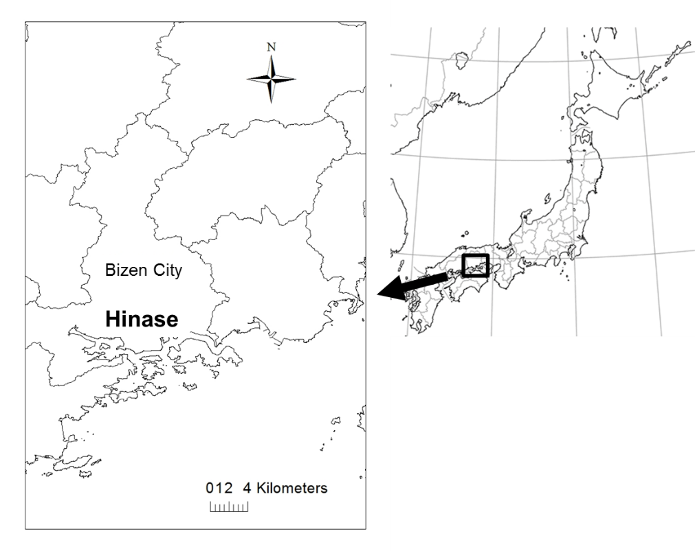
Fig. 1. Location of Hinase town, Okayama Prefecture.

III. Methods
We asked a research company to distribute a web-based questionnaire to residents who were registered in the monitoring service of Yahoo!. Questionnaire was distributed to residents living 100km within the Hinase bay from February to March of 2015. We asked the research company to gain as many samples as possible within our budget limit reflecting the average distribution of the country gender-wise and age-wise.
As for questionnaire items, we prepared 41 variables including cognitive factors and socio-demographics (Table 1 and 2). We assumed that people’s sense of place could affect their willingness to conserve the coastal area and utilized a scale developed by Arodin et al. (2012) [6] which have twenty three items consisted of biophysical, psychological, sociocultural, and political-economic variables. We also included four items measuring time-related factors; attitudes toward past and future generations. This is because previous studies revealed these time-related factors could influence people’s willingness to conserve the area [7]. Other thirteen variables included socio-demographics, residents’ experiences, and other cognitive factors.

Table 1. Questionnaire items prepared based on Ardoin et al. (2012) and Sakurai et al. (2016).
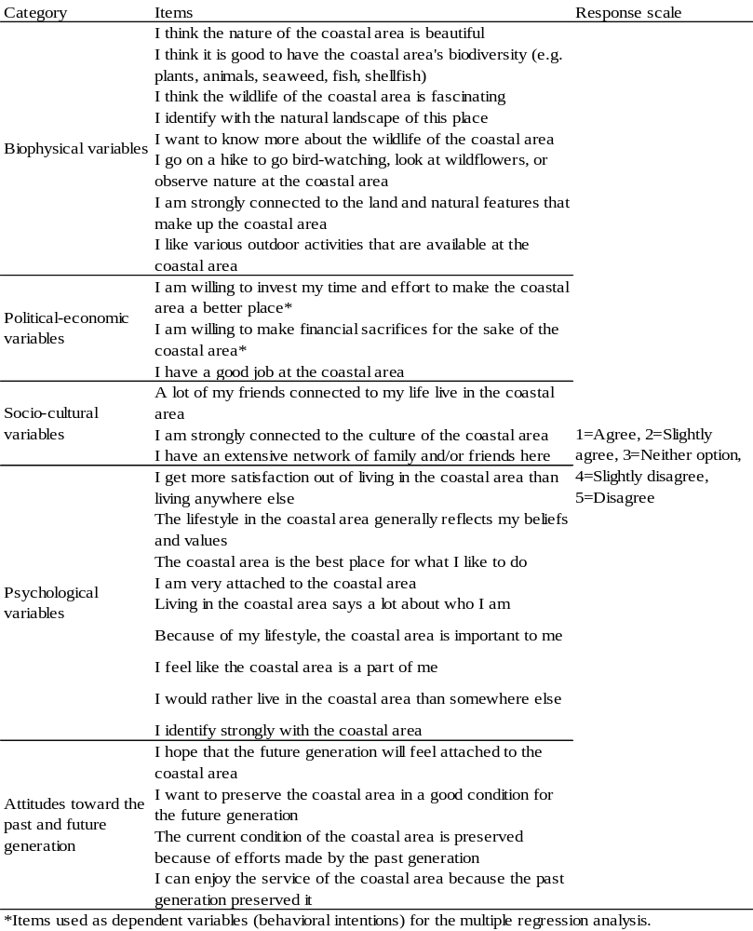

Table 2. Questionnaire items regarding socio-demographics factors and residents’ experiences and cognitive factors prepared based on Sakurai et al. (2016).
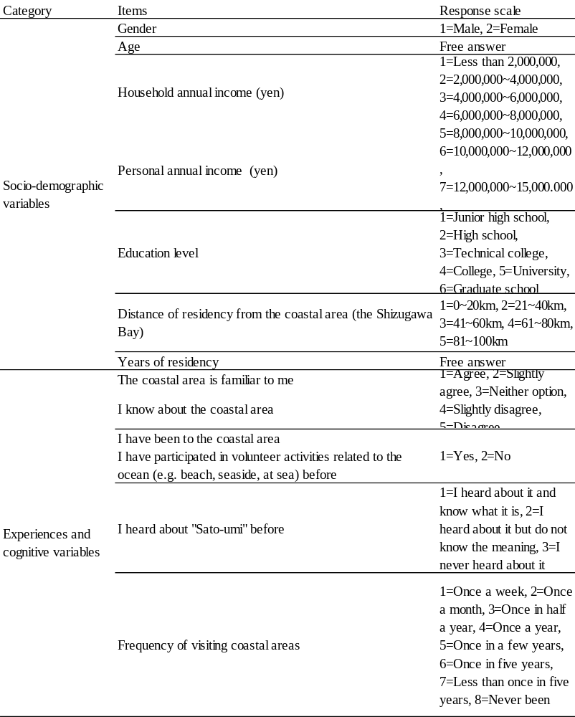

IV. Analysis
In order to understand which factors affect residents’ willingness to conserve the coastal area, we used two items; “I am willing to invest my item and effort to make the coastal area a better place”, and “I am willing to make financial sacrifices for the sake of the coastal area” as dependent variables. We conducted a multiple regression analysis and used all thirty eight items as independent variables to understand which of them affect residents’ behavioral intentions. We used a stepwise method to identify the best-fit model that had 5% significance level in F-value. In addition, we used VIF (Variance Inflation Factor) to test intercorrelation among independent variables. For all analyses, we used SPSS 18 (IBM) and set statistically significant level as p<0.05.

V. Results
We received 2,851 replies and among them, 51.5% were male and 48.9% were female and average age was 45.9 years old. Among respondents, 16.1% lived within 20km of Hinase Bay, 19.9% between 21 and 40km, 21.2% between 41 and 60km, 21.2% between 61 and 80km, and 21.6% between 81 and 100km.
The stepwise multiple regression analysis identified a model with twelve independent variables explaining residents’ behavioral intention to invest time and effort to conserve the coastal area had the best-fit (Table 3). VIF scores for three variables were more than 3 which implied that these items had potential of multicollinearity. The model had a high explanatory power (Adjusted R²=0.673) and majority of dependent variable was explained by these twelve factors. The best-fit model identified by the stepwise multiple regression analysis to explain residents’ behavioral intention to make financial sacrifices to conserve the coastal area included twelve variables that significantly influenced the dependent variable (Table 4). One variable had VIF score of more than 3 implying a potential of multicollinearity. This model also had a high explanatory power (Adjusted R²=0.598) and majority of dependent variable was explained.

Table 3. Multiple regression analysis with residents’ willingness to invest their time and efforts for conservation of the coastal area as a dependent variable and socio-demographic and cognitive factors as independent variables. B=standardized coefficient. n=2,581.
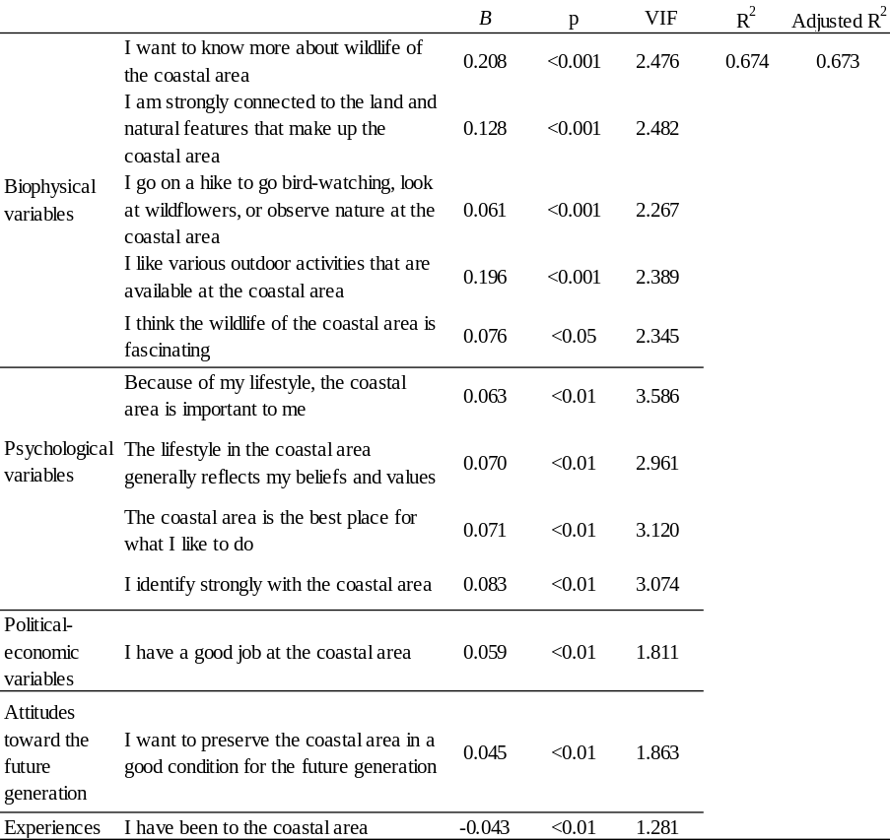

Table 4. Multiple regression analysis with residents’ willingness to make financial sacrifices for conservation of the coastal area as a dependent variable and socio-demographic and cognitive factors as independent variables. B=standardized coefficient. n=2,581.
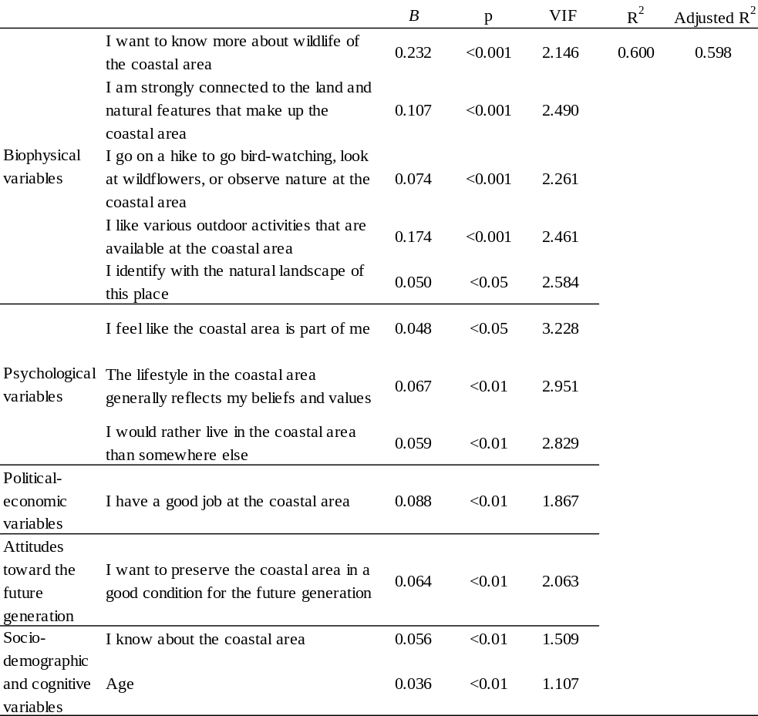

VI. Discussion
Results of the stepwise multiple regression analysis revealed that two independent variables that had the strongest influence on residents’ willingness to conserve the coastal area (two dependent variables) were same; “I want to know more about the wildlife of the coastal area” and “I like various outdoor activities that are available at the coastal area”. These imply that in order to foster residents’ willingness to get involved in coastal conservation, it is effective to promote significance and attractiveness of wildlife and outdoor activities at the coastal area. Government officials and/or managers of coastal area could conduct outreach (such as distributing leaflets) to educate local residents regarding wildlife and to increase their curiosity toward nature of the coast. In addition, organizing participatory outdoor activities such as cleaning up the beaches and bird-watching would affect people’s conservation intentions.
Our findings followed results of the previous study [3] conducted in different region of Japan (Shizugawa, norther part) which revealed that multiple biophysical variables had influence on residents’ willingness to conserve the coastal area, and especially their intentions to know more about wildlife had the strongest effect. These imply that cognitive factors that influence residents’ willingness to participate in coastal conservation have similar trend and people have similar cognitive mechanism throughout the region. Meanwhile, there were certain variables that affected residents’ behavioral intentions for conservation which had no significant effect in the previous study. One of these variables was “I have a good job at the coastal area” which affected two behavioral intentions in this study. This implies that in Hinase and surrounding area, whether people area satisfied with the job they have at the coastal area affect their willingness to coastal conservation. When organizing outreach programs and/or participatory activities targeting residents, it would be important to consider the common factors that affect people’s behaviors throughout regions and also specific factors that have particular effects at a certain region.

V II. Acknowledgment
This paper is based on the result of the research project “S-13 Development of Coastal Management Method to Realize the Sustainable Coastal Sea” (Head Researcher: Prof. Dr. Tetsuo Yanagi) by the Ministry of the Environment of Japan. The authors want to thank the EMECS International Center and Prof. Dr. Tetsuo Yanagi for their support on this research.

V III. References
[1] Ministry of Internal Affairs and Communications. 2012. Concentration of population
into three biggest metropolitan area and depopulation. (in Japanese). http://www.soumu.go.jp/johotsusintokei/whitepaper/ja/h24/html/nc112130.html (accessed June 22, 2015).
[2] A. Charles, Sustainable Fishery Systems. Oxford: Blackwell Science. p. 370, 2001.
[3] R. Sakurai, T. Ota, T. Uehara, and K. Nakagami, “Factors affecting residents’ behavioral intentions for coastal conservation: Case study at Shizugawa Bay, Miyagi, Japan,” Marine Policy 67, pp. 1-9, May 2016.
[4] T. Tanaka, “Satoumi with eelgrass and oyster: Hinase town of Okayama prefecture,” Journal of Survey Research and Information ECPR 1, pp. 21-26, 2014. (in Japanese).
[5] T. Yanagi, Development Theory of Sato-umi. Tokyo: Koseisha Koseikaku. p. 161, 2010. (in Japanese).
[6] N.M. Ardoin, J.S. Schuh, and R.K. Gould, “Exploring the dimensions of place: a confirmatory factor analysis of data from three ecoregional sites,” Environmental Education Research 18(5), pp. 583-607, 2012.
[7] T. Fuse, “Investigation and verification of consciousness related to environmental ethics derived from nature experience through environmental education including the concept of sustainability,” Environmental Education 22(2): 3-13, 2013. (in Japanese with English abstract).

